Mission 4 — DNA Preservation for Precision Biotechnology

- Bacterial DNA and Its Potential Biotechnological Relevance

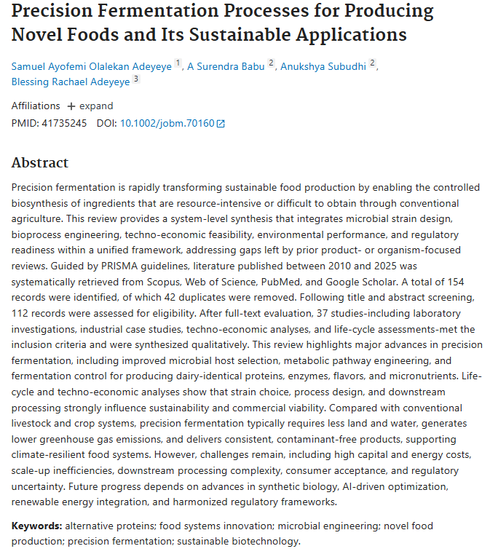
Overall: DNA is the molecule that stores the genetic information required for the structure and function of living organisms. In biotechnology, specific genetic sequences can provide microorganisms with instructions for producing valuable proteins or other biological products. This principle forms the basis of recombinant biotechnology and precision fermentation, in which microorganisms can function as biological production platforms. Precision fermentation uses microbial “cell factories” to produce selected high-value compounds in a controlled process.
Biological / Biotechnological Element | Main Function | Potential Relevance
DNA | Stores genetic information | Preservation of biological instructions
Gene / coding sequence | Contains information for a specific biological product | Recombinant protein production
Promoter / regulatory elements | Control when and how genetic information is expressed | Controlled gene expression
Genetic construct | Combination of functional DNA elements | Introduction of a desired biological function
Microbial host / cell factory | Uses genetic information to produce a target product | Precision fermentation
Recombinant protein | Protein produced using introduced genetic information | Pharmaceuticals, biomaterials, diagnostics
Insulin | Therapeutic protein produced through recombinant biotechnology | Diabetes treatment
Recombinant collagen | Collagen produced using engineered biological systems | Biomaterials, regenerative medicine
DNA integrity | Degree to which DNA remains structurally intact | Determines whether genetic information is preserved
Functional preservation | Ability of preserved genetic information to remain biologically usable | Essential for future biotechnological applications
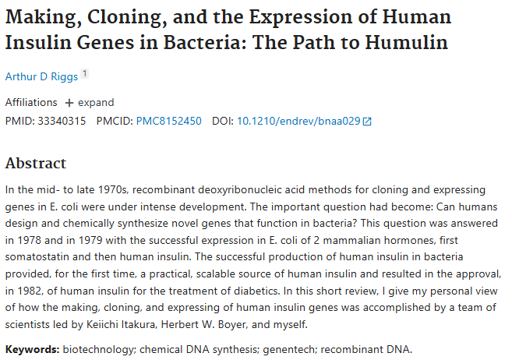
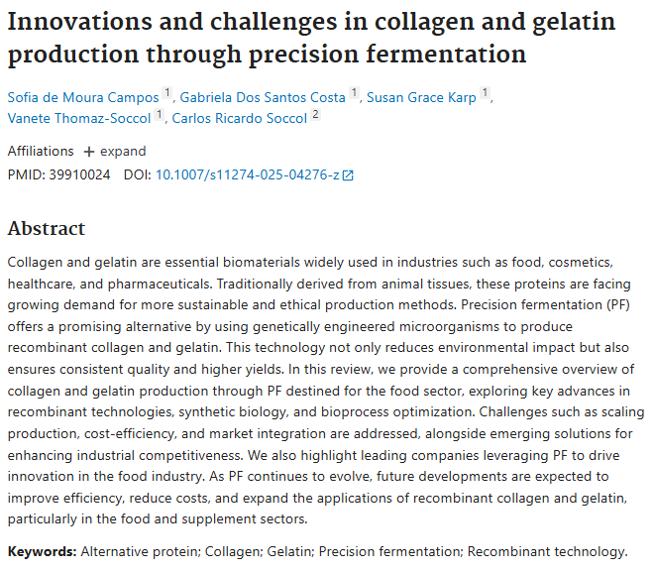

Recombinant human insulin is a classic example: human insulin has been produced using microorganisms such as E. coli, demonstrating that microbial systems can serve as biological factories for medically important proteins. Recombinant collagen is also being actively investigated and produced using engineered microbial systems for biomaterial and healthcare applications.
Overall: DNA can be viewed as the information layer of biotechnology: preserve the information, and it may remain available for use in a suitable biological production system.
- The Problem
https://www.nasa.gov/ames/space-biosciences/radiation-biophysics-lab/
https://www.nasa.gov/ames-engineering/spaceflight-division/biosentinel/
Future space exploration will expose biological materials to environmental stresses that can affect DNA structure and function. NASA conducts extensive research into how radiation and other spaceflight conditions cause DNA damage and alter genetic processes. These effects are important because damage to genetic material can influence cellular function, adaptation and long-term biological stability.
Importantly, this problem is already being investigated in actual space missions. NASA's BioSentinel mission uses dry biological material in a CubeSat to study DNA damage caused by the deep-space radiation environment, while other NASA investigations examine changes in microbial DNA architecture, DNA repair and genomic stability during spaceflight.
This raises a broader biotechnology question:
Can genetic information be transported through an extreme environment while preserving its structural integrity and potential biological function?
If genetic information could reliably survive transportation and remain usable, biological manufacturing systems could potentially be designed to operate as highly compact and flexible biotechnology platforms.
3. Proposed Solution — Preserving Genetic Information for Future Biomanufacturing
Our mission proposes transporting dried bacterial DNA to approximately 24 km altitude and investigating whether the genetic material retains its structural integrity after exposure to the stratospheric environment.
The DNA would be sealed inside a protected experimental module and exposed to the flight environment. A corresponding ground-control DNA sample would remain under terrestrial conditions.
After recovery, the flight and control samples would be compared using appropriate laboratory methods to determine whether measurable changes occurred in the DNA.
The experiment would therefore have two distinct questions:
Stage 1 — DNA integrity
Was the DNA structurally preserved after flight?
↓
Stage 2 — Functional preservation
Can the recovered genetic material still perform its intended biological function in an appropriate laboratory system?
This distinction is critical. A DNA molecule can appear physically intact while still containing changes that affect its biological function. Therefore, “good DNA quality” would not by itself prove that the bacterium can produce a target molecule.
A successful functional result would provide evidence that the genetic information remained biologically usable after the flight.
The long-term biotechnology concept is based on the principle of precision fermentation: appropriately engineered microorganisms can act as microbial cell factories for the controlled production of valuable biological products. Examples include recombinant insulin and recombinant collagen.
The actual development of such production strains and their use for manufacturing would remain a separate, controlled laboratory stage after the flight.
4. Relevance of the idea
The relevance of this mission lies in the possibility of connecting space-environment research with biotechnology.
DNA is much easier to transport and store than an entire living biological production system. Therefore, demonstrating preservation of genetic information under extreme environmental exposure could contribute to the broader concept of portable biological manufacturing.
This is particularly relevant to future exploration missions, where transporting large quantities of medicines, proteins or other specialized materials from Earth may be difficult.
Instead of transporting every finished product:
Genetic information → biological production system → target product
could potentially become a more flexible model for future biotechnology.
For example, precision fermentation is already being investigated for producing recombinant proteins such as insulin and collagen, including products relevant to medicine and regenerative materials.
Therefore, the proposed mission establishes a much more fundamental first step:
Can genetic information survive an extreme atmospheric journey while preserving the potential to remain biologically functional?
A positive result would not mean that insulin or collagen can immediately be manufactured in space. Rather, it would provide experimental evidence supporting further research into DNA preservation, biological manufacturing and portable biotechnology systems for extreme environments.
Mission Concept
Dried bacterial DNA
↓
Stratospheric exposure (~24 km)
↓
Recovery
↓
DNA integrity analysis
↓
Functional validation in an appropriate laboratory system
↓
Potential application in precision biotechnology
Core idea
Preserve the genetic information first — then determine whether the information remains functionally usable for future biological production.

